Randall Bramblett - Pine Needle Fire quotes
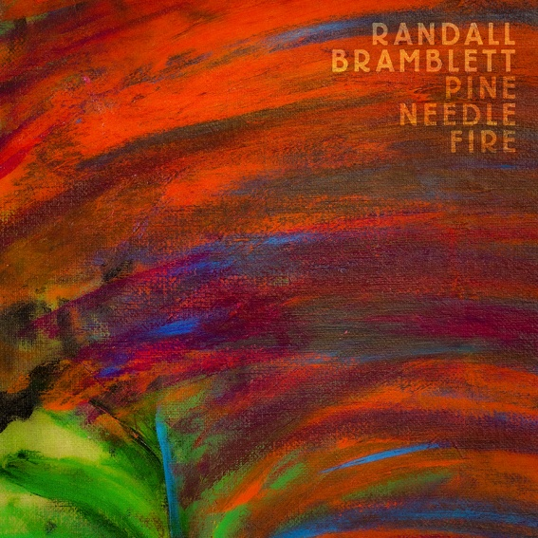
"On Pine Needle Fire, Randall Bramblett proves himself once again as one of the most important contemporary musical artists of our day." - Elmore Magazine
"Imagine a world where musicians play concerts: These songs would have folks on their feet." - The Associated Press
"...marvel at his ability at this stage of his five-decade career to put out one discerning and evocative album after another...relevant and downright cool." - Relix Magazine
“(PNF) is arguably the most lyrically intimate, poetically revealing outing in his career. It is exactly the kind of record the 2020s call for. – AllMusic, Thom Jurek
"As we've come to expect from him, Bramblett has delivered another masterpiece, a guided tour through a unique soundscape that makes us all feel at home." -No Depression
"On Pine Needle Fire, Randall Bramblett proves himself once again as one of the most important contemporary musical artists of our day." - Elmore Magazine
"... there is plenty to unpack, and it's all consistently engaging. 4 out of 5 Stars" - American Songwriter Magazine
"... some real knockout moments of beauty." - Flagpole
"Randall Bramblett has a singular soulful sound, and thankfully, a wealth of creative energy looking forward. He has a catalog of consistently strong albums and Pine Needle Fire is the latest to join this esteemed list." - Glide Magazine
"Pine Needle Fire continues a remarkable string of recordings that set richly literate Southern reflections to frameworks of soul, blues and jazz-informed pop." The Best Albums of 2020 List - Lexington Herald Leader
"Pine Needle Fire is a first-class Southern soul stew, beautifully played, written, and sung." - Lyric Magazine

"On the new album Pine Needle Fire, Georgia soul man Randall Bramblett's warm, weathered tenor gives voice to average folks who are hanging on, and he provides a beat to keep them going," - The Associated Press
“You could scan the roots landscape and have a hard time finding a more complete and compelling musical mind with more earned soul, songwriting chops and percussive sense than Bramblett.” Craig Havinghurst, String Theories

”… he uses expansive, hypnotic arrangements: winding guitars, jazzy undertones, sturdy melodies sent into the ether. 8 out of 10” - Uncut Magazine

